Schrijven B 1
Beispiel 2

Foto’s – Wat zal er gebeuren?

Bekijk de foto’s. Beschrijf in het kort wat er de situatie vooraf gegaan is, in welke situatie de persoon zich bevindt en wat er heel zeker zal gebeuren.

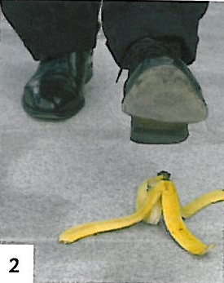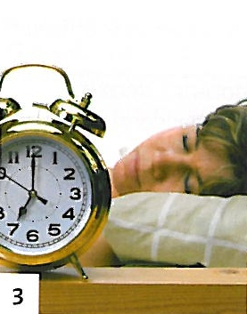

Quelle: Welkom! Niederländisch für Anfänger, Lehrbuch, Seite 163, Klett-Verlag

_________________________________________________________________________

__________________________________________________________________________

__________________________________________________________________________

_________________________________________________________________________

__________________________________________________________________________

__________________________________________________________________________

_________________________________________________________________________

__________________________________________________________________________

_________________________________________________________________________

__________________________________________________________________________

_________________________________________________________________________

__________________________________________________________________________

__________________________________________________________________________

_________________________________________________________________________

__________________________________________________________________________

__________________________________________________________________________

_________________________________________________________________________

